Status report OpenCL setup, board test

Contents

Platform 2

System 2

Quartus stack 2

Prequisites 2

Compilation (board test) 3

Board preparation 4

Deployment 5

Execution 6

Conclusion 7

# Platform

## System

* Core i7 6500u, 8GB RAM
* Windows 10 Pro x64
* Windows Subsystem for Linux
* PuTTY

## Quartus stack

* Quartus 2 14.1.0.186
* AOCL 14.1.0.186
* SoC EDS 14.1.0.186

# Prequisites

1. Setup Altera Quartus stack
2. Setup USER[1] environment variables
   1. Altera OpenCL License (Create LM_LICENSE_FILE)
   2. Altera OpenCL binaries (Add to PATH)
   3. Altera Board package path (AOCL_BOARD_PACKAGE_ROOT)

# Compilation (board test)

1. Go to “C:\altera\14.0\hld\board\terasic\de1soc\examples\boardtest”
2. Prompt> aoc device/boardtest.cl --sw-dimm-partition -o bin/boardtest.aocx
3. Open “C:\altera\14.1\embedded\Embedded_Command_Shell.bat” embedded shell
   1. A Cygwin [2]shell opens [https://www.cygwin.com/]
   2. Go to /cygdrive/c/altera/14.1/hld/board/terasic/de1soc/examples/boardtest[3]
   3. Build the board test project (See image x)

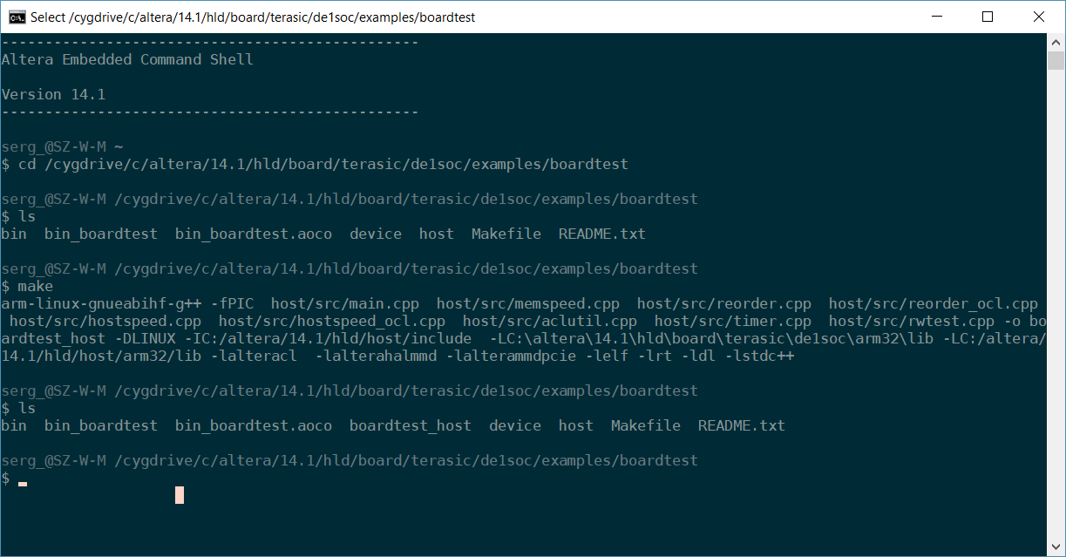

Figure Altera Embedded Command Shell

# Board preparation

Prior to deployment the DE1-SoC has to be up and running.

A prepared flash card with a linux base system is required.

1. Connect the power, USB/UART and Ethernet connectors.
2. Start PuTTY, select the proper COM port and set the baudrate to *115200*
3. Log in as “root”. A password is not required.
4. Set up a (static) ip address, e.g *192.168.0.123*

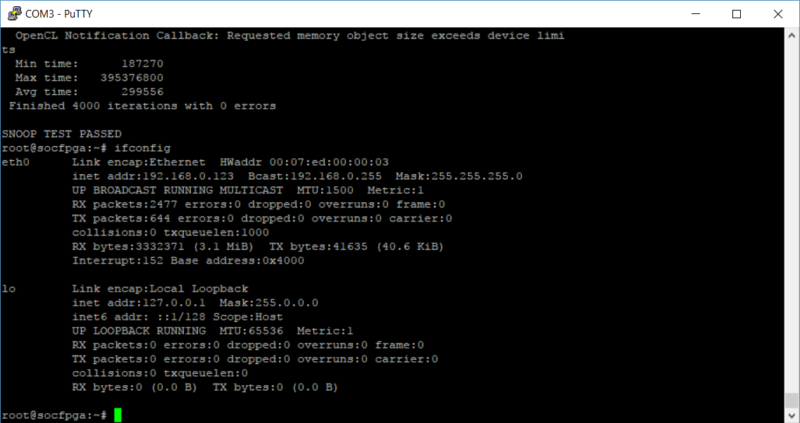

Figure Board's IP configuration

# Deployment

From a terminal:

* Copy ACL device configuration: *scp bin/boardtest.aocx* [*root@192.168.0.123:/home/root*](mailto:root@192.168.0.123:/home/root)
* Copy OpenCL host application: *scp boardtest_host* [*root@192.168.0.123:/home/root*](mailto:root@192.168.0.123:/home/root)

These commandos copy files to the target board via SSH[4].

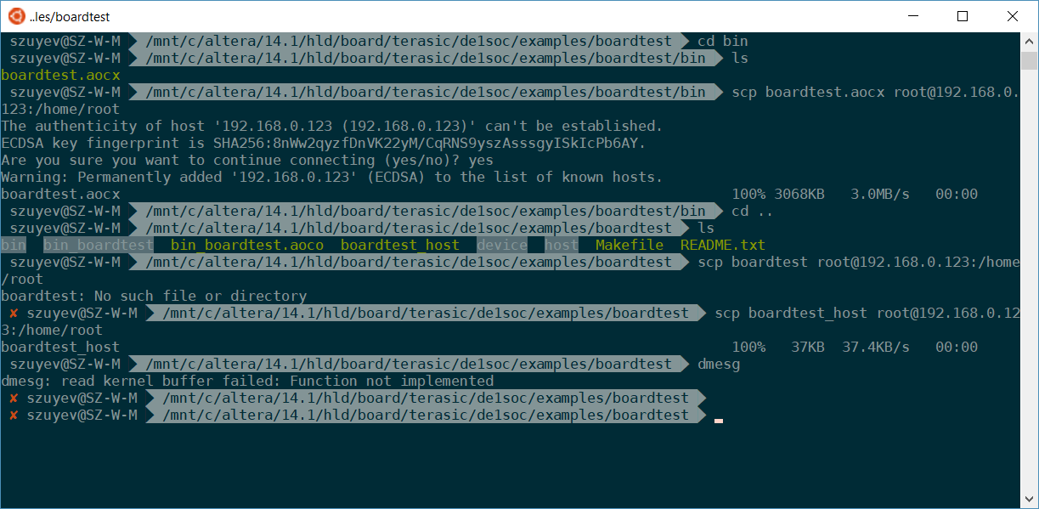

Figure Copy necessary files to the board

# Execution

* Make boardtest_host executable: *chmod +x ./boardtest_host*
* Prepare the OpenCL environment*: source ./init_opencl.sh*
* Program the device: *aocl program /dev/acl0 boardtest.aocx*
* Execute the OpenCL host application: *./boardtest_host*

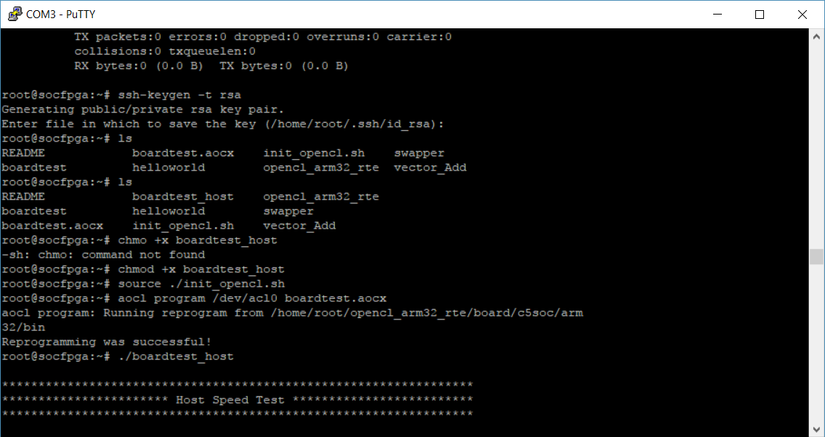

Figure Steps prior to execute the OpenCL program on the board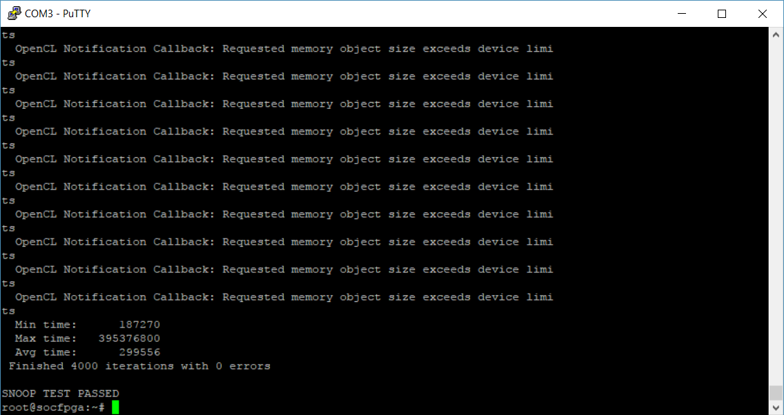

Figure OpenCL board test passed

# Conclusion

* At least one system (Sergej Zuyev’s) is properly configured.
* We can deploy and run OpenCL programs on the provided DE1-SoC
* We can use this knowledge for our own LBP-Operator implementation

1. Systemwide variables won’t work without adapting Altera’s own environment variables
2. POSIX emulation layer + tools for windows, https://www.cygwin.com/
3. To access a host path via Cygwin shell /cygdrive “prefix” is required (mountpoint)
4. Secure Shell